LoTW Synchronization from Club Log

Aki Yoshida JA1NLX

1.0 GENERAL

Logger32 provides a feature which synchronizes LoTW Credit Granted status with the status on Club Log database. You should be a user of Club Log and LoTW to use this feature.

2.0 Preparation

- Upload your all QSOs to LoTW
- Go to https://secure.clublog.org/lotw/ and click “Download confirmed QSOs from LoTW”

Details are not explained here. Please read guide provided by Club Log in the page above.

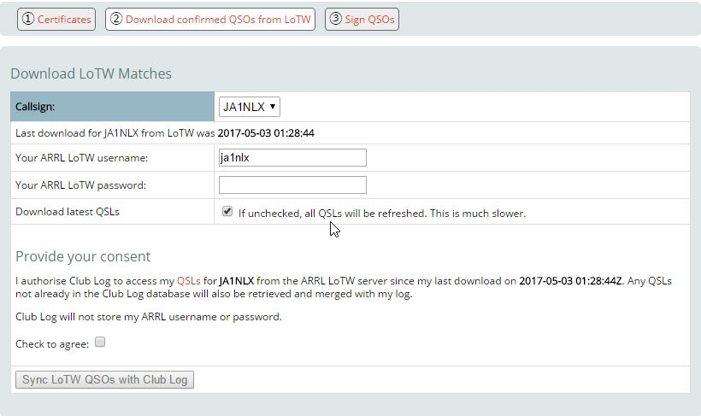

CLOTW_1

3.0 SYNCHRONIZE LoTW from Club Log

Click File and Synchronize LoTW (from Club Log.)

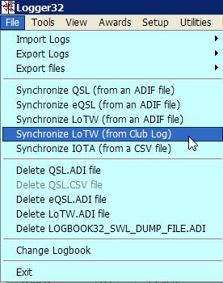

CLOTW_2

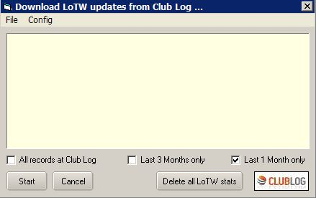

CLOTW_3

Click Config and type Callsign, Password and eMail address for Club Log. Click Apply.

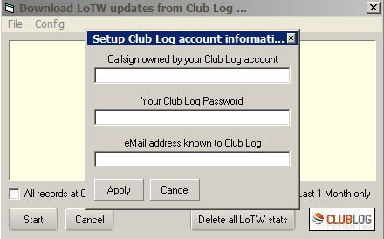

CLOTW_4

If you want to clear all LoTW credit granted stats in your Logbook then click “Delete all LoTW stats”
In this case you must download confirmed QSOs from LoTW with “If unchecked, all QSLs will be refreshed. This is much slower” unchecked. If this option is checked then Logger32 get only newly credit granted flag. See CLOTW_1

If you want to synchronize Logbook by confirmed QSOs for last 1 month then check Last 1 month only.
If you want to synchronize Logbook by confirmed QSOs for last 3 months then check Last 3 months only.
If you want to synchronize Logbook by all confirmed QSOs at Club Log then check All records at Club Log.

Click Start to synchronize.

4.0 Note

It may take a long time to complete update when Logger32 need to update for many QSOs. (just after deleting all LoTW Credit Granted status) However once it updated then it is faster next time.

Downloaded QSOs records are saved as “LoTW records from ClubLog.txt” (JSON format) in the Logger32 folder. Sample below.

["VE7AHA","2013-12-31 23:41:41","12","CW","C"],["W9WI","2013-12-29 22:38:06","15","CW","C"],["3W1T","2013-12-27 00:36:35","10","CW","C"],["YB4IR\/8","2013-12-25 22:19:21","20","CW","C"],["YF1AR\/8","2013-12-23 11:39:13","20","SSB","C"],["YB4IR\/8","2013-12-23 03:18:01","15","CW","C"],["YF1AR\/8","2013-12-22 05:51:26","15","SSB","C"],["YB4IR\/8","2013-12-21 23:25:48","17","CW","C"],["ZM90DX","2013-12-18 02:42:55","12","CW","G"],["RW110RAEM","2013-12-10 07:49:41","12","CW","C"],["V63XG","2013-12-10 07:34:17","15","CW","C"],["T32RC","2013-12-09 08:53:15","30","CW","C"],["V63XG","2013-12-09 07:18:09","20","CW","C"],["J69DS","2013-11-29 22:57:36","15","RTTY","C"],["C6AUM","2013-11-29 12:28:09","40","CW","C"],

